Hi Sunny –

Thanks for putting together the API functionality… its working great!

I’d like to do the following for the next steps of the project…

1 – Current pairs repository

Can we make a function that will scrape the following website to identify all eligible currency pairs that can be queried by the Kraken api? The website to scrape would be the following: <https://coinmarketcap.com/exchanges/kraken/>

In addition to the currency pairs, can we also scrape the liquidity column as well? I plan to keep track of the historical liquidity of each pair. (see below)

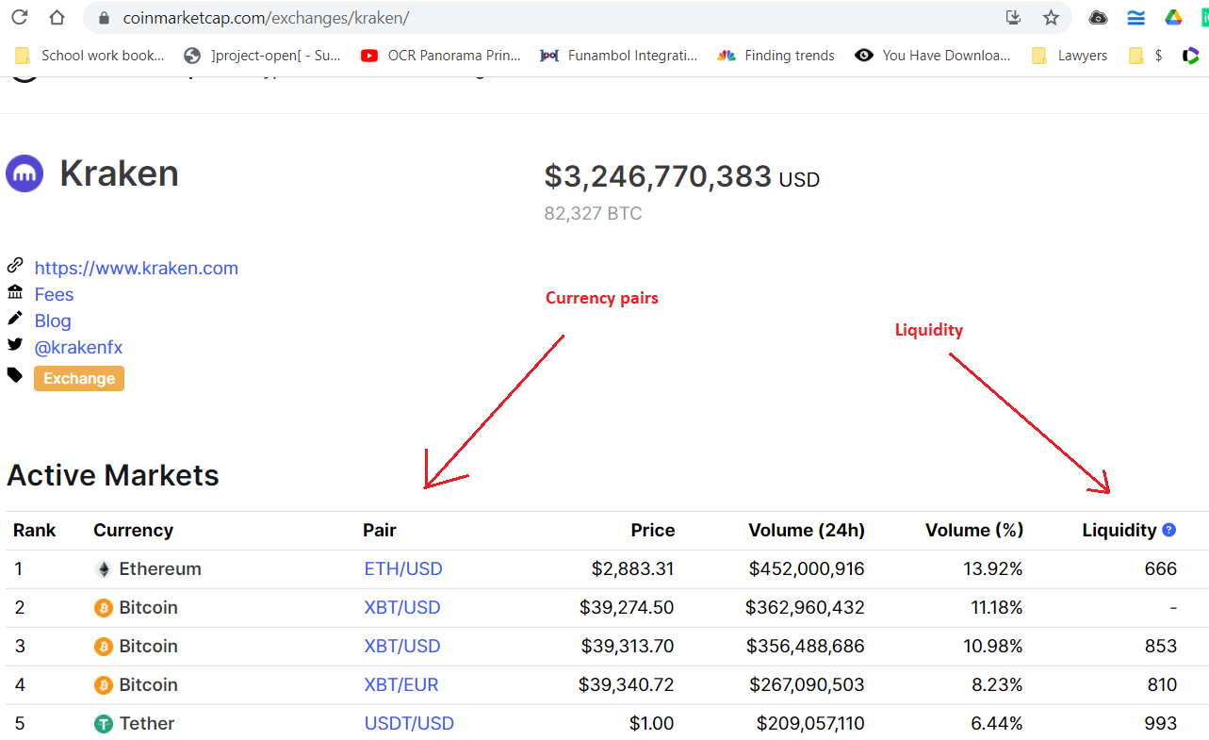

2 – Logic for tracking multiple tickers…

Can we build out the capability for the api to continually track data for multiple currency pairs? For the sake of testing… lets pick 10 currency pairs. Any 10 will do.

I think the question here is how we should plan on saving the data locally in a way that’s best for its eventual use.

Another python program will eventually use the data for reading and making trades. Its also likely that instead of just a single program, that there will be multiple trading programs running simultaneously.

The two considerations I think we should keep in mind are:

a – other programs will eventually rely on the data for use

b – speed – it will be important for those other program(s) to be able to quickly read the data so they can react as quickly as possible (since the plan is to trade with 1-minute data and market conditions can change quickly)

My hunch is that saving the data to local CSV or text files will likely be fine for this purpose. But please let me know if you disagree or think there is an alternative that may be better.